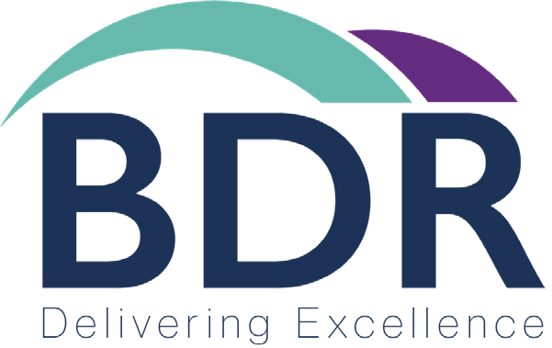

Complaints Handling Procedure
CODE OF PRACTISE ON COMPLAINT HANDLING & DISPUTE RESOLUTION

BDR Group Holdings
Complaints Handling Procedure - 2021

BDR Group Holdings is committed to providing all of our customers with the highest level of service at competitive prices. While we may not provide all the components of our services ourselves, we do take responsibility for the level of service you receive. In the unlikely event that you experience any problems, we will liaise with our suppliers to ensure that any issues are resolved quickly and efficiently.

CONTACT DETAILS
We can be contacted in writing at:
BDR Group Holdings, Caspian House, Timothy’s Bridge Road, Stratford-upon-Avon, Warwickshire, CV37 9NR
Account Management team can be contacted as follows:
Telephone: 0845 313 60 20
Facsimile: 0845 313 60 30
E-mail: customerservices@bdrgroup.co.uk Website: www.bdrgroup.co.uk

When you phone us, our Account Management team will ask you about your complaint and endeavor to resolve the issue while you are on the line. We may have to ask you questions to confirm that we are speaking to the right person, in order to protect the privacy of the information we hold on you. Should you require a response in writing, please ask. In the unlikely event that you have cause for complaint about any aspect of our service please follow the procedure below:

STEP 1: Contact our Account Management Team
The Account Management team will investigate your complaint and assist in resolving any issues you may have in line with your terms and conditions of service. Calls to BDR Group Holdings may be recorded for monitoring and training purposes.

STEP 2: Contact the Director
If you feel that your complaint has not been adequately resolved you can ask for the matter to be escalated and referred to the Sales Director. They will review your case and further attempt to resolve the problem. Should the matter not be resolved, a formal written complaint should be made to the Billing Manager.

STEP 3: Arbitration
At BDR Group Holdings we believe that it is in everyone’s interest to attempt to resolve disputes without 3rd party involvement. However, if it has been 8 weeks from the date you first contacted us to complain, or if you have received a letter from us saying that your complaint has reached “deadlock”, you may refer your complaint to our arbitration service, The Ombudsman Services.

We can provide you with full details of these services. Complaints to Ombudsman must be made within 6 months of reaching deadlock or, if deadlock is not agreed, within 9 months of making a complaint to BDR Group Holdings.

STEP 4: OFCOM
If you believe that your complaint has not been handled in like with the BDR Group Holdings complaints procedure or followed the independent arbitration process, please contact The Office of Communications (Ofcom) who will review the matter. However, Ofcom CANNOT alter or review Ombudsman Services. For more details of Ofcom’s role please refer to their website.

STEP 5: Court Action
Should all other attempts to resolve the issue fail, court action can be started.

OBTAINING A COPY OF THIS CODE
A copy of this code is published on our website. Alternatively, it is available on request to any of our customers, free of charge.

CONTACT DETAILS OF RELATED ORGANISATIONS
Ofcom, Contact Centre, Riverside House, 2a Southwark Bridge Road, London, SE1 9HA Tel: 0845 456 300
Website: www.ofcom.org.uk

Ombudsman Services, Communications, PO Box 730, Warrington, WA4 6WU Tel: 0330 440 1600
Website: www.ombudsman-services.org

ADDITIONAL INFORMATION
This code has been approved by Ofcom for the purpose of Section 2 Communications Act 2003.

